**Unearthing the environmental impact of Human activity: A Global Co2 Emission Analysis.**

***INTRODUCTION:***

**Overview:**

Global Co2 Emission Analysis is a comprehensive study that examines the levels of carbon dioxide emissions produced by various countries around the world. Co2 is a greenhouse gas that contributes to climate change, and its excessive emission is a major environmental concern. The analysis of Co2 emissions provides valuable insights into the current state of global climate change, as well as the effectiveness of global efforts to reduce emissions. The analysis can also provide useful information for policy makers, scientists and individuals to make informed decisions bout ways to reduce emissions and mitigate the effects of climate change.

**Purpose:**

The purpose of a global Co2 emission analysis is to understand and evaluate the current levels of carbon dioxide emissions produced by various countries and regions around the world. The analysis can help identify the major contributes to global Co2 emissions, and the sources of those emissions, such as transportation, energy production and industrial processes.

The analysis also aims to provide insights into the effectiveness of existing policies and measures aimed at reducing emissions, as well as identifying areas where further action is needed. It can help inform decision-makers in developing new policies and strategies to reduce Co2 emissions and mitigate the impacts of climate change.

Additionally, the analysis can help raise awareness about the urgent need to address climate change and encourage individuals, communities and organizations to take action to reduce their carbon footprint and support global efforts to tackle climate change.

***II. PROBLEM DEFINITION & DESIGN THINKING:***

**Empathy** **Mapping:**

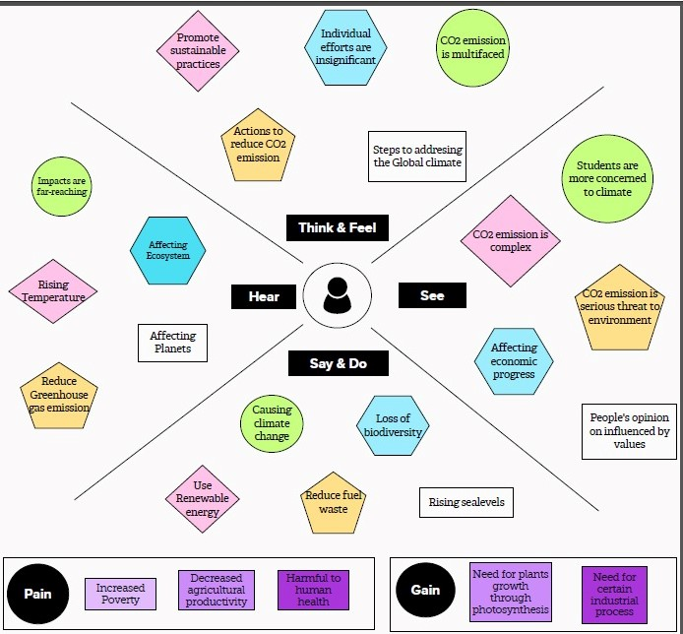

**Brainstroming**:

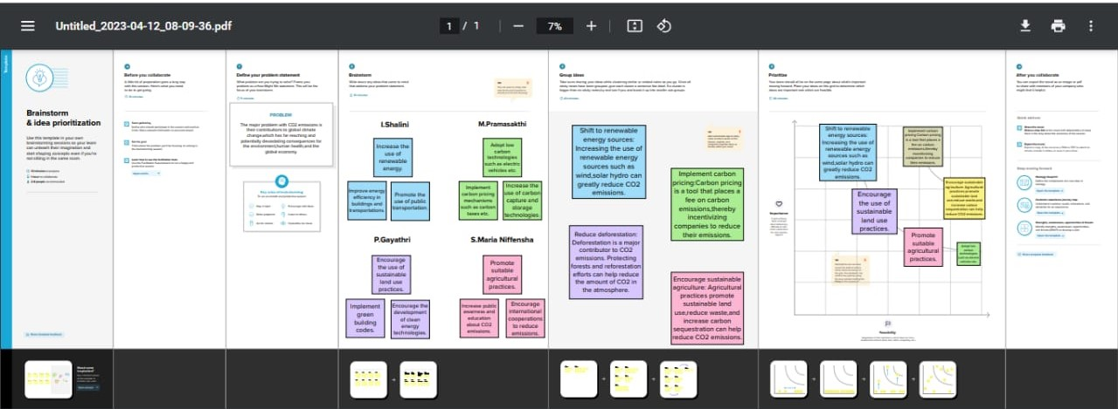

***III. RESULT:***

**DASHBOARD** 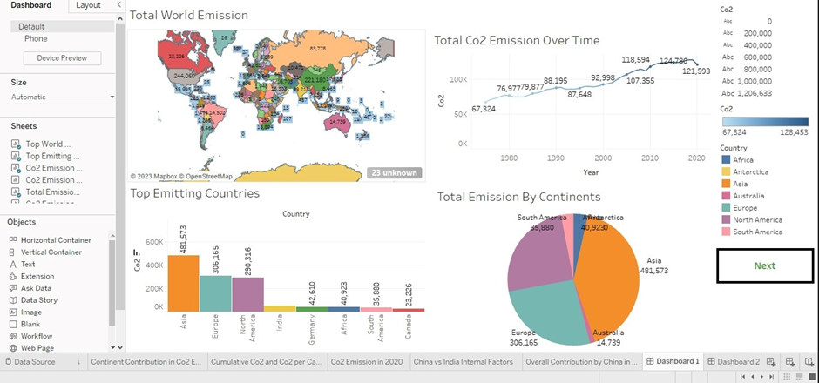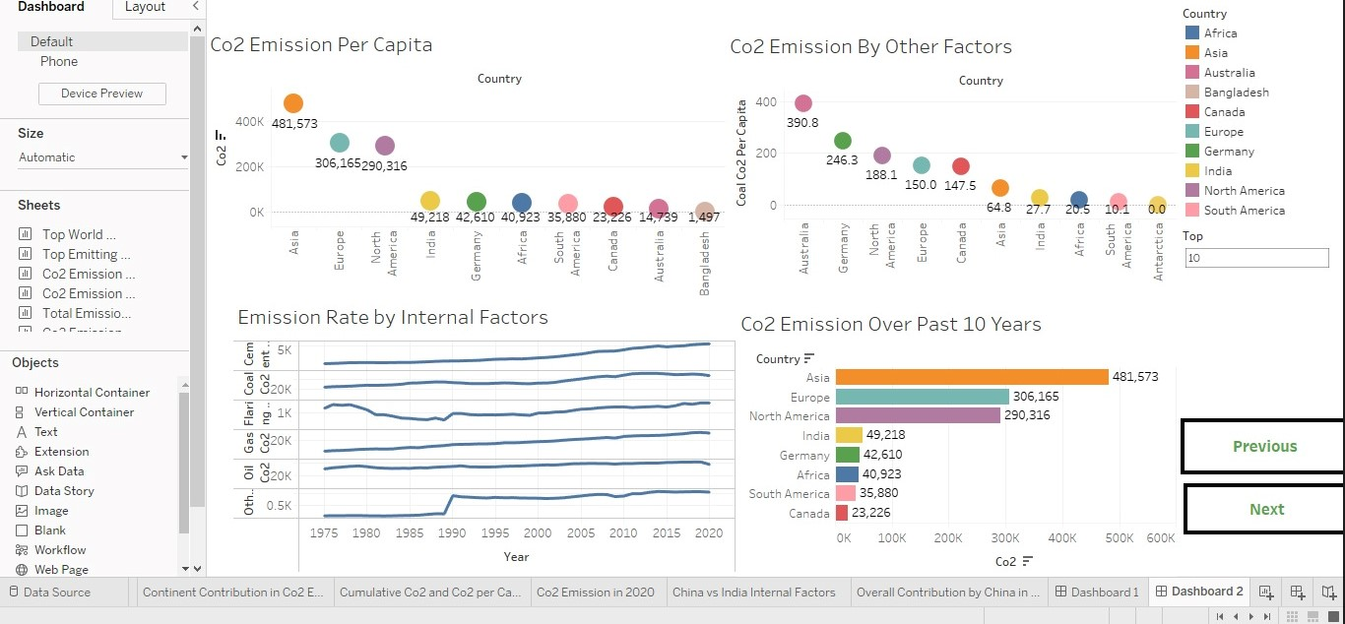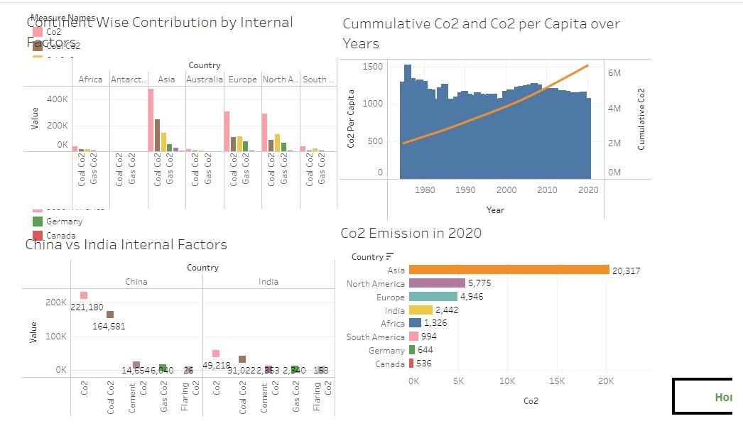

**STORY:** 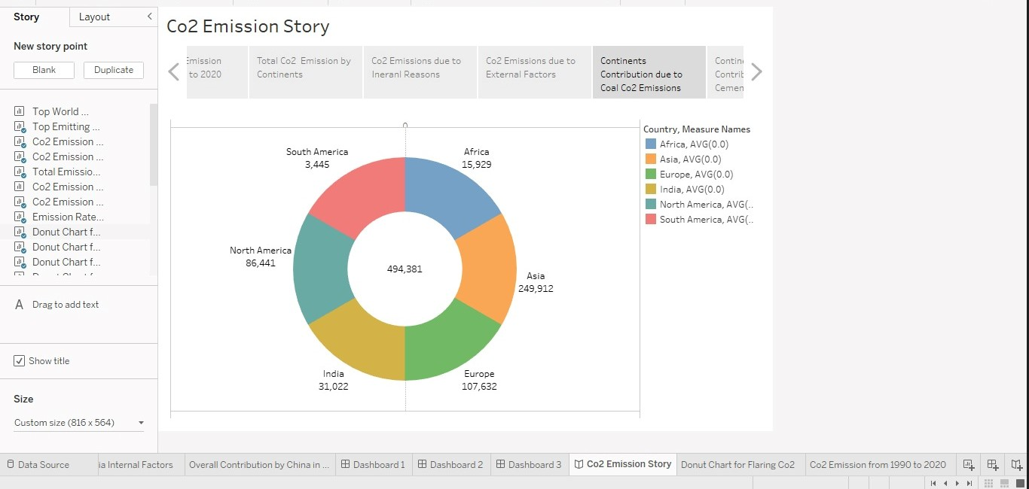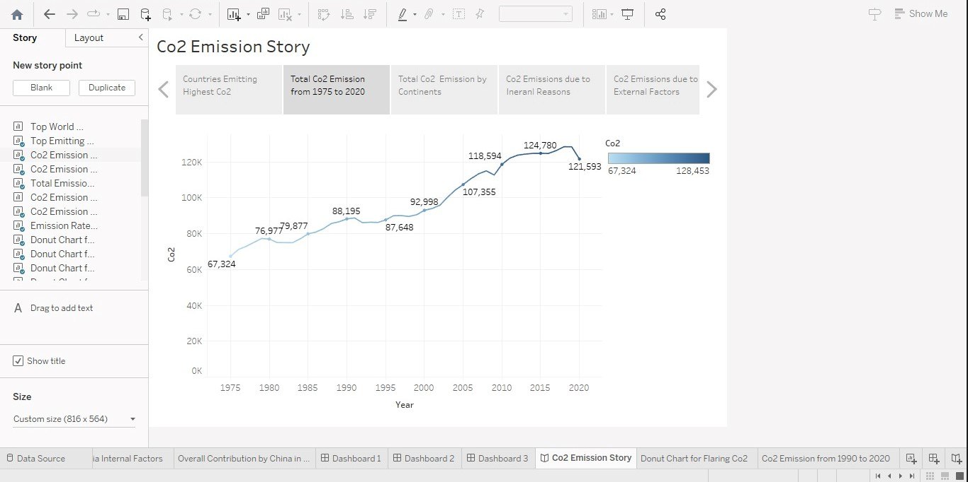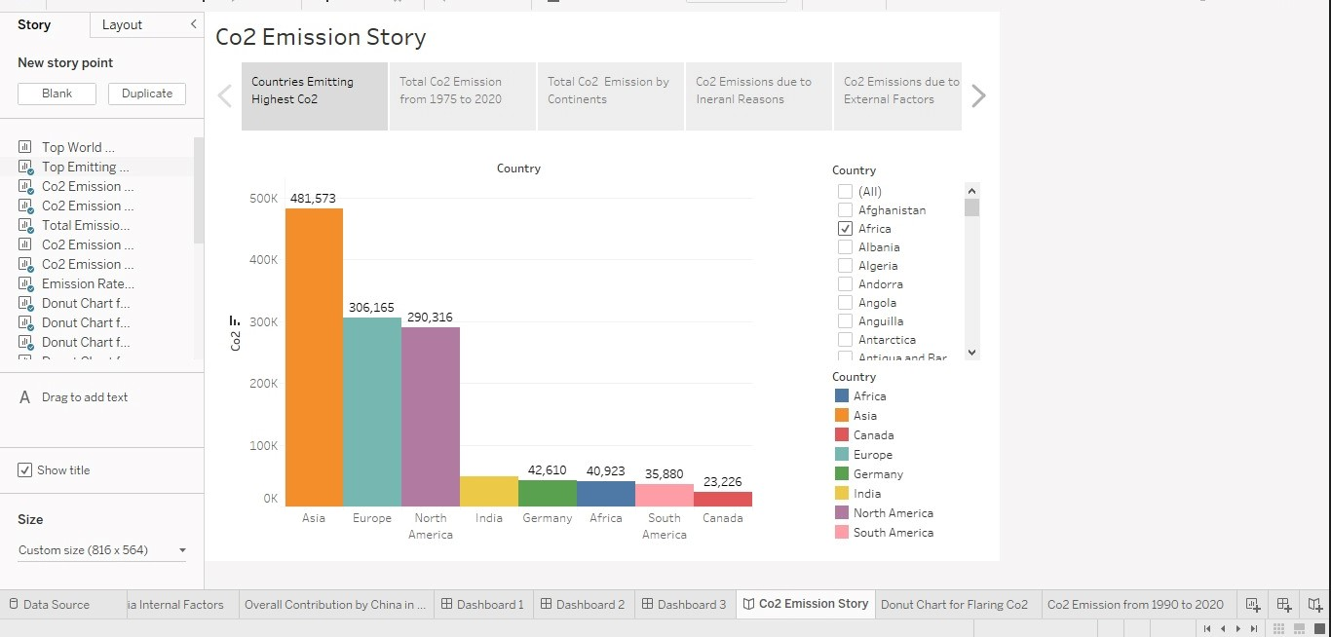

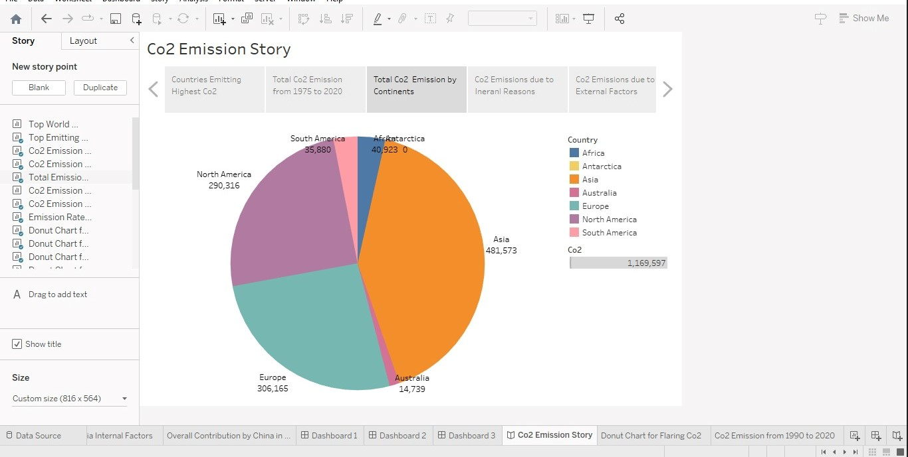

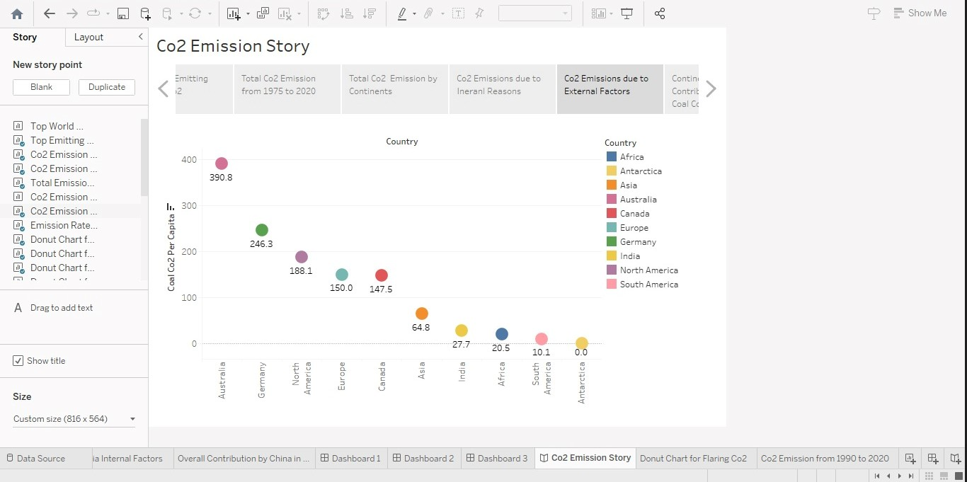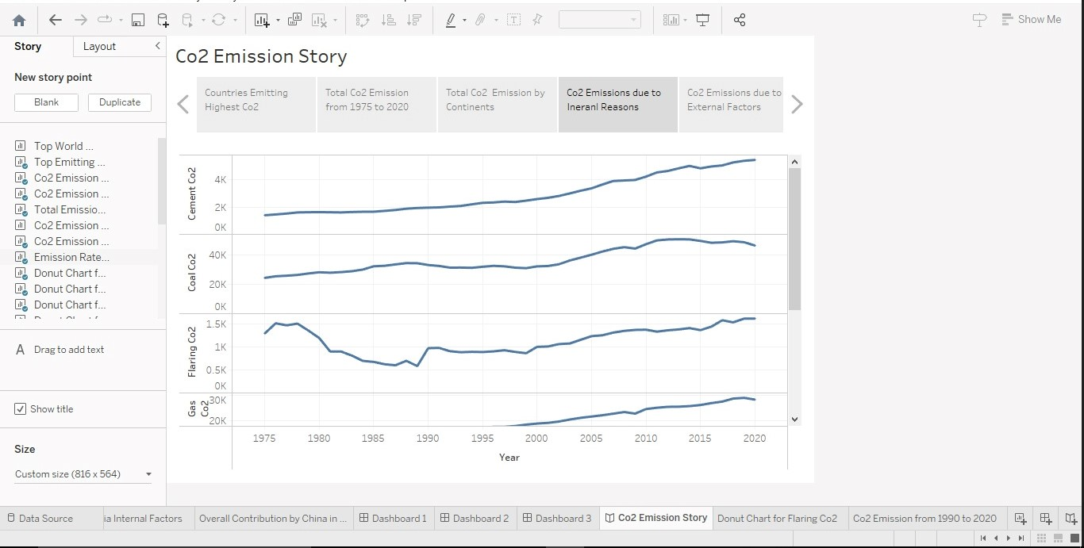

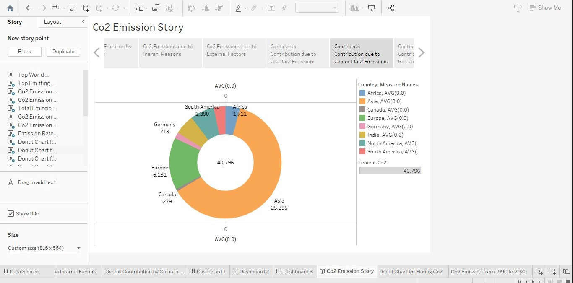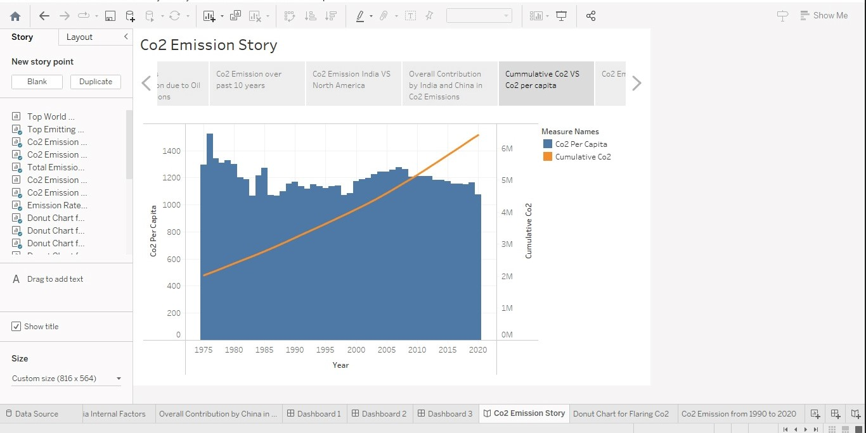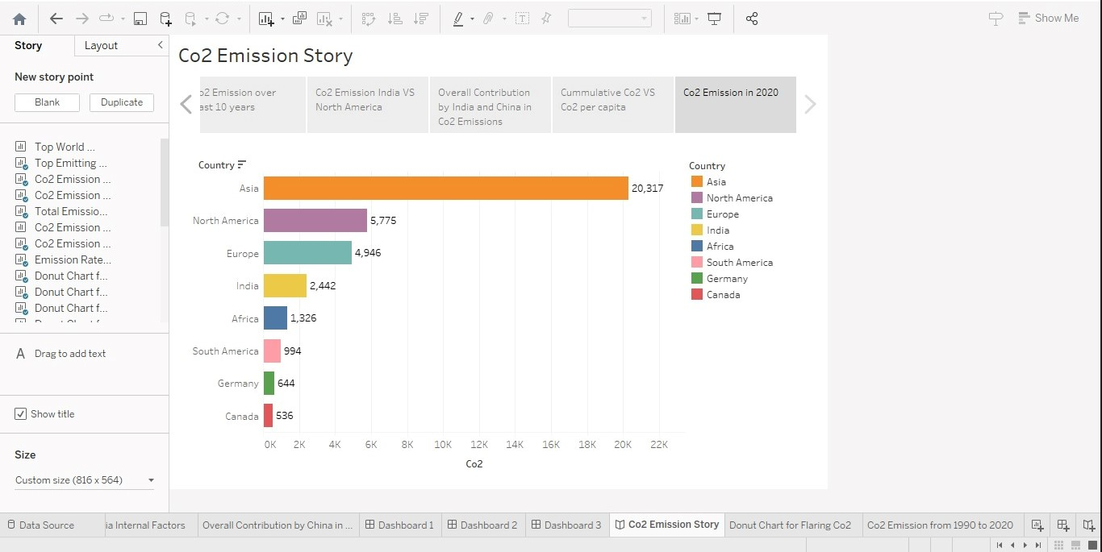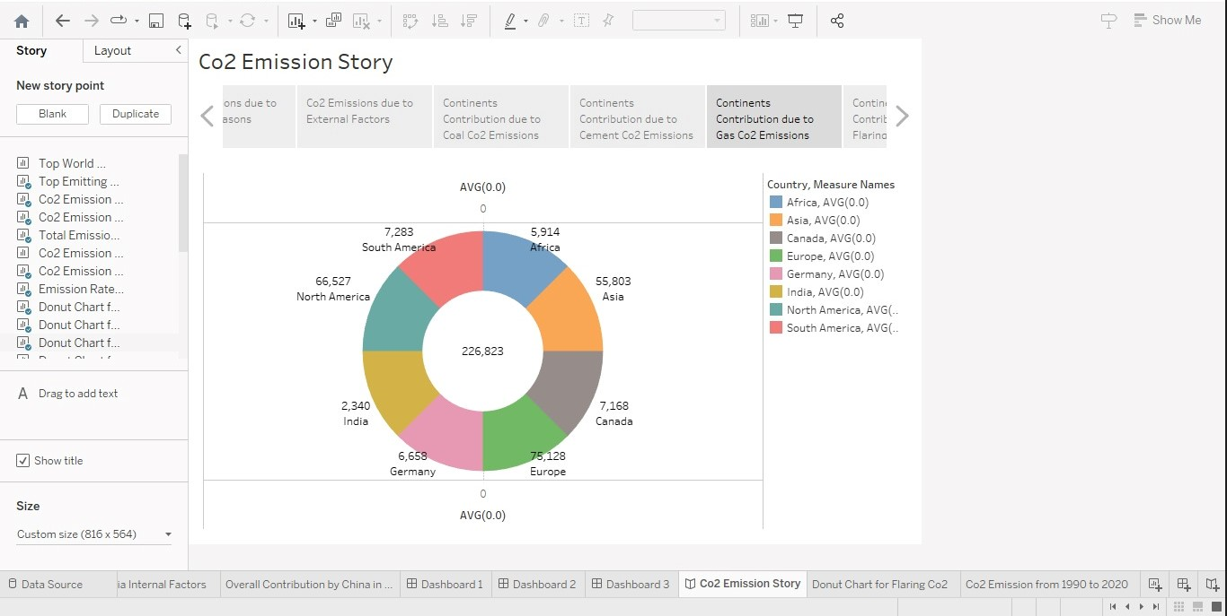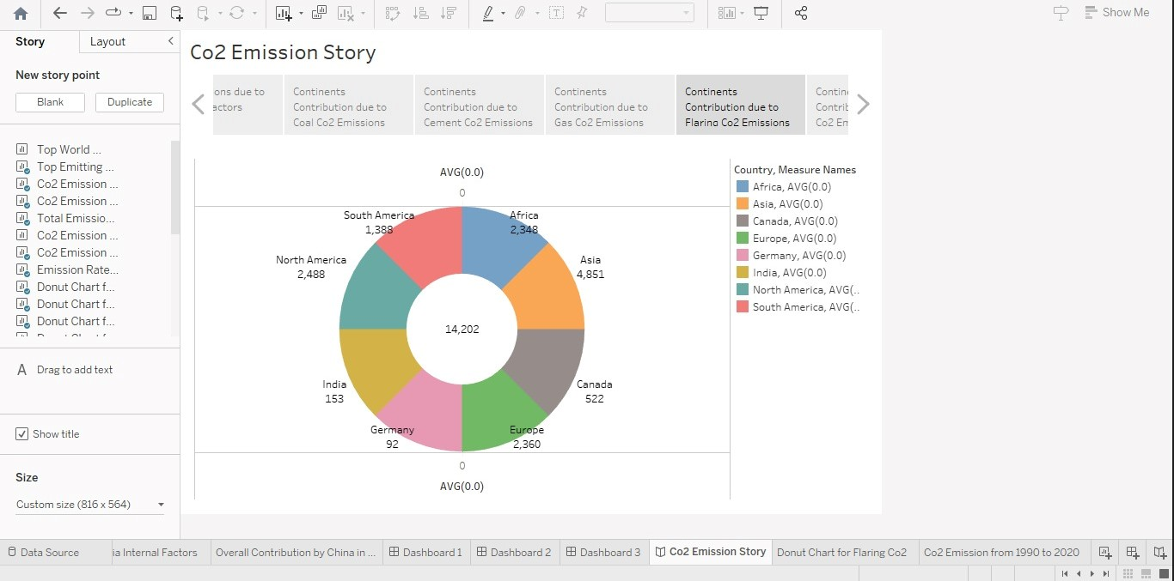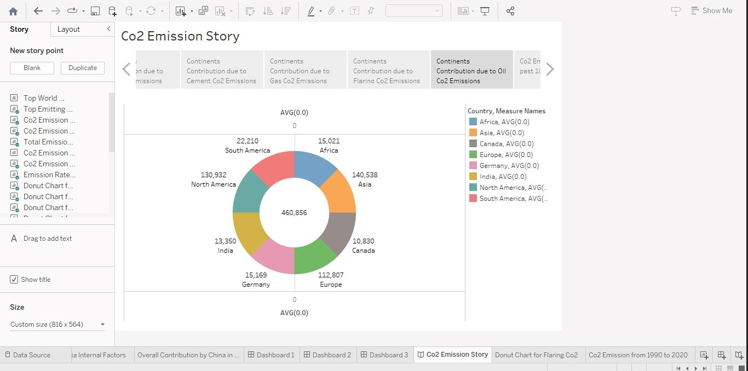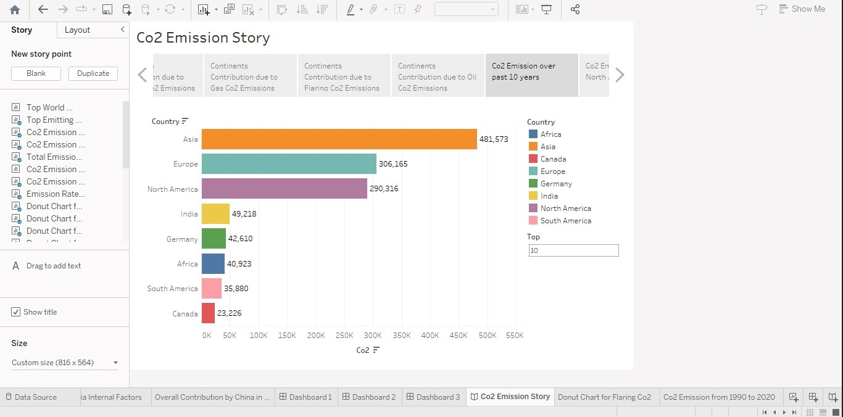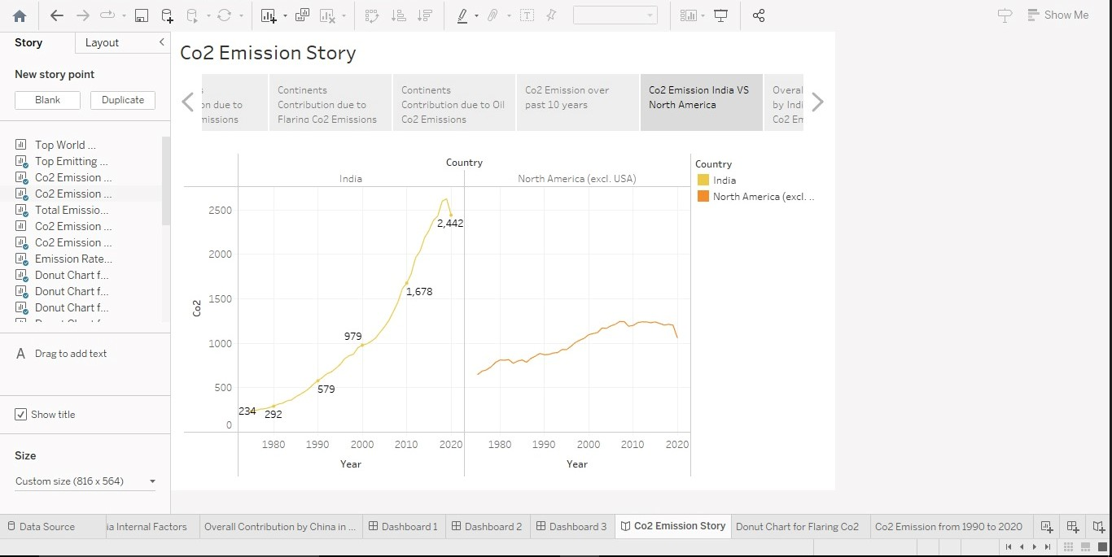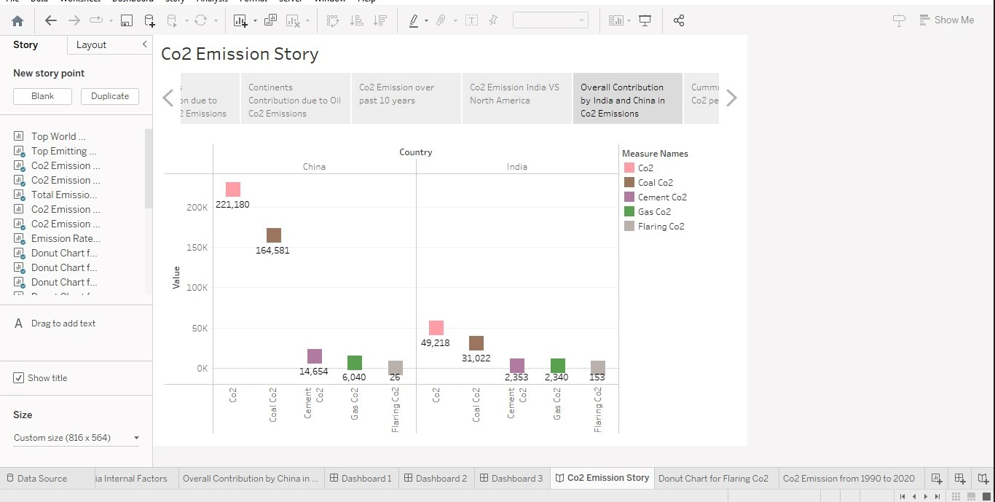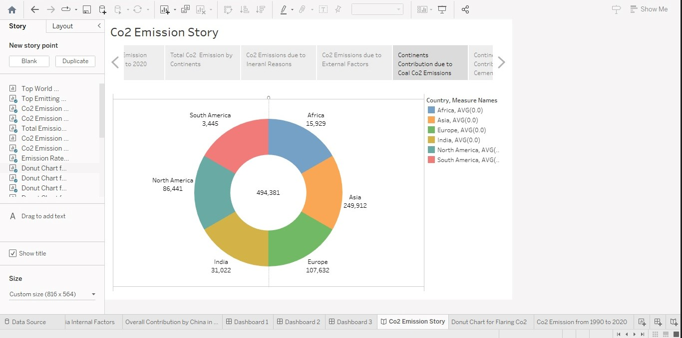

***IV. ADVANTAGES & DISADVANTAGES :***

**ADVANTAGES:**

There are several advantages of a global Co2 emission analysis:

* ***Identifying major contributors:*** Allowing policy makers and governments to target specific sectors for reduction efforts.
* ***Monitoring Progress:*** Reduction of emissions targets set by international agreements, such as the Paris agreement.
* ***Raising Awareness:*** Encourage individuals and organizations to take action to reduce their carbon foot print.
* ***Encouraging innovations****:* Encourage innovations in developing new technologies and approaches to reduce emissions.
* ***Improving accountability***: It can help hold governments and corporations accountable for their actions and encourage them to take responsibility for their emissions.

**DISADVANTAGES:**

There are also some potential disadvantages of a global Co2 emissions analysis:

* ***Data Accuracy****:* Incomplete data can lead to inaccurate conclusions and policy recommendations.
* ***Methodological differences:*** Different methodologies foe measuring can make it difficult to compare emissions data across countries and regions.
* ***Economic implications:*** Policies aimed at reducing emission can have economic implications, such as job losses in carbon intensive industries.
* ***Limited Scope:*** Broader environmental impacts, such as the impact of land use and deforestation on climate change.

***V. APPLICATIONS:***

* The analysis provides the data necessary for international agreements and negotiations, such as the Paris agreement, which set targets for emission reductions and rely on accurate and up-to-date emission data.
* Global CO2 emissions analysis can be used by companies to access their carbon footprint and develop strategies to reduce their emissions.
* Many companies have adopted emissions reduction targets and reporting standards in response to growing public concern about climate change.
* The analysis can be used to educate the public about the cause and effects of climate changes and the importance of taking action to reduce emissions.
* The analysis provides a valuable source of data for research into the cause and effects of climate change, as well as the effectiveness of policies and strategies to reduce emissions.

***VI. CONCLUSIONS*:**

Total World Emission:

* This world map indicates about the Co2 emission across the world.
* This line graph shows the variations of Co2 emission over the time during 1980 to 2020.
* Bar diagram expresses the view on the top countries which emits Co2.
* In Continents, the total Co2 emission is discussed in this pie chart.
* This Charts shows the Co2 emission per capita among the countries.
* Similarly, this charts indicates other factors of Co2 emission in the countries.
* In this line chart, these lines specifies the internal factors of Carbon di-oxide emission.
* This bar diagram shows the increase of Co2 emission over past 10 years of the countries all over the world.
* This table shows the contribution of the continent by internal factors of Coal Co2 and Gas Co2.
* The linear graph explain the cumulative Co2 and Co2 per capita over years.
* This table shows the difference between China and India in internal factors.
* In 2020, Co2 emission is discussed in this bar diagram for some countries.

***VII. FUTURE SCOPE*:**

The future scope of global CO2 emission analysis is significant, as the world continues to grabble with the impact of climate change. Here are some potential areas of focus:

* ***Regional and local analysis:*** While global analysis is important there is also a need for regional and local analysis to identify emissions hotspots and tailor policy responses to local circumstances.
* ***Integrated analysis:*** Combining emissions analysis with other environmental and socio-economic could help identify the relationship between emissions and other environmental and social factors. This could lead to more effective and integrated policy solutions.
* ***Real time monitoring:*** Advances in technology and data collection could make it possible to monitor emissions in real-time, allowing for more accurate and up-to-date information on emission trends.
* ***Scenario Planning:*** Using emission analysis to develop scenarios for future emission could help inform policy and decision-making and identify potential pathways to a low-carbon future.

***VIII. APPENDIX:***

* ***Emissions inventories***: These are data sets that estimate the amount of CO2 emissions released by different sectors, such as transportation, energy production, and industrial processes. Inventories can be developed at the national, regional, or local level.
* ***Carbon footprint analysis:*** This method calculates the total amount of CO2 emissions associated with a particular emissions associated with a particular product, service, or activity, taking into account all emissions generated throughout its lifecycle.
* ***Energy consumption data:*** This includes data on energy production and consumption, such as the amount of energy generated by different sources (e.g., coal, natural gas, renewables) and the amount of energy consumed by different sectors (e.g., residential, commercial, industrial).
* ***Modeling and simulation:*** These methods use computer models and simulations to estimate future emissions based on different scenarios, such as changes in energy use, technology adoption, or policy interventions.
* ***Satellite data:*** Remote sensing data from satellites can be used to track changes in land use, deforestation, and other activities that contribute to CO2 emissions.
* ***Life cycle assessment:*** This is a method used to assess the environmental impact of a product, service, or activity throughout its entire lifecycle, taking into account all inputs and outputs, including emissions.